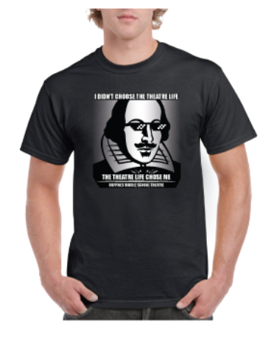
Huffines Theatre Shirt

Available to all Huffines Theatre students, parents, and Huffines teachers.

Please fill out the following form and return the payment, Cash or Check (Made out to Huffines).

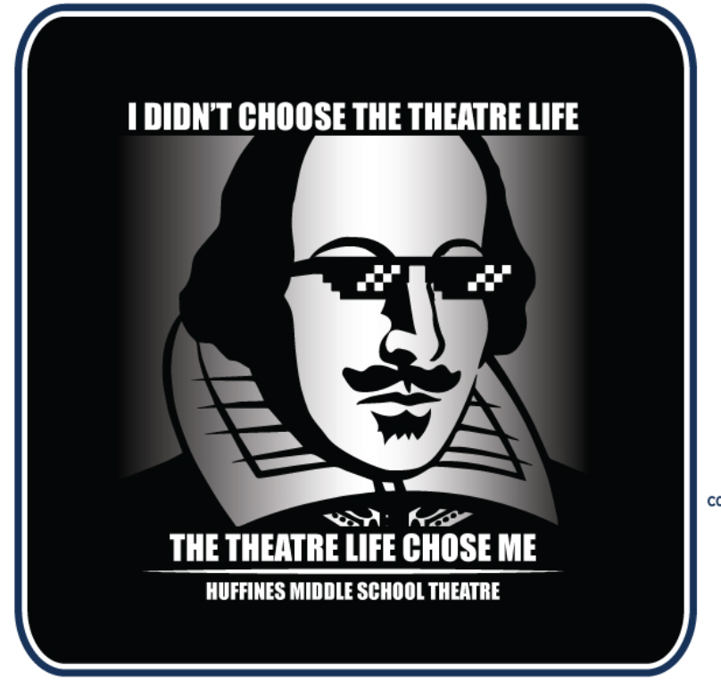
The order for shirts will be placed once I have received money from everyone.

The hoodie will be black with white lettering. These are all adult sizes.

Money is due Friday October 23.

---------------------------------------------------
Huffines Theatre Hoodie Order

Parent Name: _________________________________________
Student Name: _________________________________________
Parent Email: _________________________________________

# of Shirts Ordered _______
SIZE | QTY | COST
Small |  | $11
Medium |  | $11
Large |  | $11
XLarge |  | $13
XXLarge |  | $13
Total Payment _______
Cash _______ Check _______
Turned in on _______

