Character Skeletons

Objective: You are going to design an outfit for one of the characters listed below.
Step One: Pick a character from the list below.

LAUREL, 38, an attractive, well mannered woman.

JULES, (male) a marine biology graduate student. Twenty-eightish, uncomfortable, excitable, literal

JO, (female) an undergraduate journalism student. Twenty-twoish, strong skeptical, physical

LAURIE JAMESON: Laurie, a very attractive, fifty four year old woman in natural fibers and long dangling earrings, sits on top of a desk. She takes very good care of her skin and seems very dynamic as she lectures.

LUCY, 4 years old. Has a vivid imagination.

MR. MARMALADE, Lucy’s imaginary friend. Dresses nice. Never has any time for Lucy.

Step Two: Read the character description several times. See what you can learn about the character just from those few sentences.

Step Three: Plan a costume for that character using the magazines on your table. Your outfit must have SHOES, PANTS, and SHIRT. Also, you need to have at least 2 extra PROPS that the character might use. Cut what you want out of the magazines and glue it together on the paper at your table.

Step Four: Write three sentences on the back of your paper describing your character.
- Bob likes to eat Rocky Rhode ice cream.
- Bob is addicted to his cell phone.
- Bob always wears a baseball hat.

Step Five: Turn your finished paper into the purple shelf. Make sure your first and last name are on the back. Make sure your character’s name is on the front.

Example:
(front)
Monica
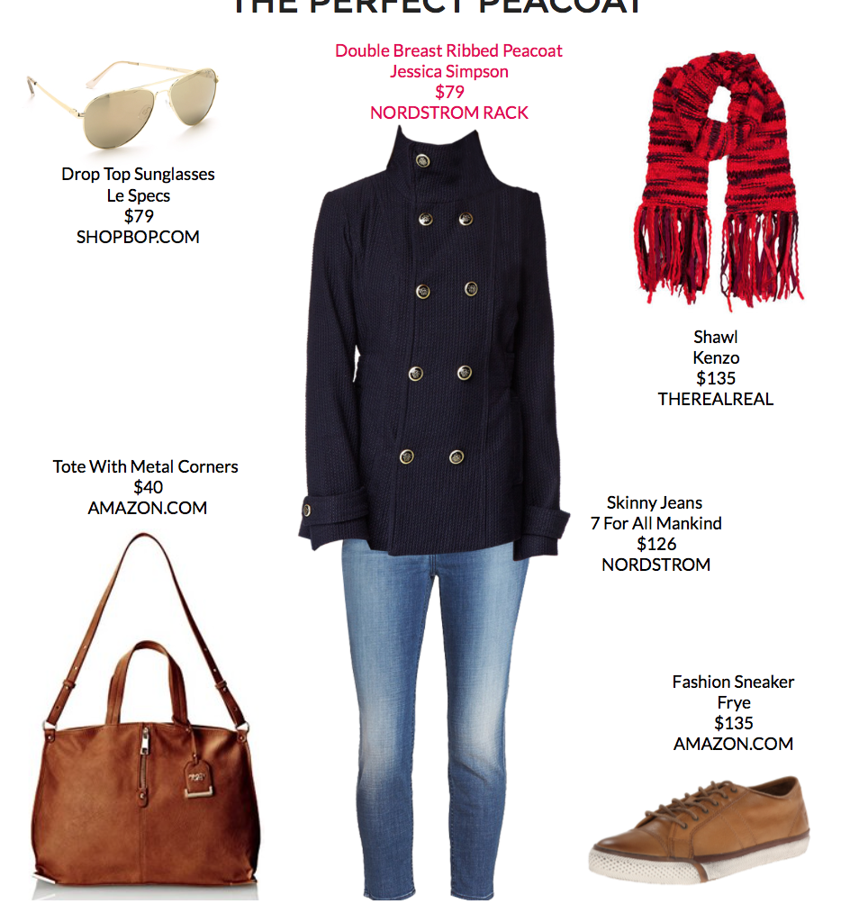
(back)

- Monica loves to match scarves to her outfit.
- Monica has to stand a lot at work, so she likes comfortable shoes.
- Monica loves to wear Ray Bans.

Ms. Downs

